DAD 220
Professor Hastings
Ollie Connett
November 26, 2023

Module 5 Major Activity
1.Write SQL commands that capture specific, usable data that can be used in your analysis.
- Analyze the results of queries to identify specific information that can be presented in your summary.
  - Sales by region:
    - Analyze sales data by state to determine where the company has the largest customer base.
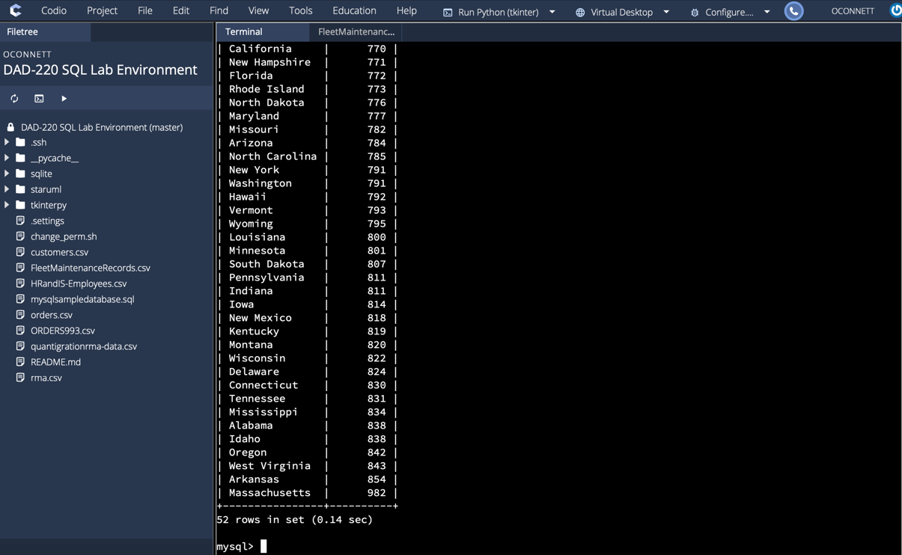
The largest customer base for the company is located in Massachusetts with 982 customers, followed by Arkansas with 854 and West Virginia with 843.
    - Analyze the data to determine the top three products sold in the United States.
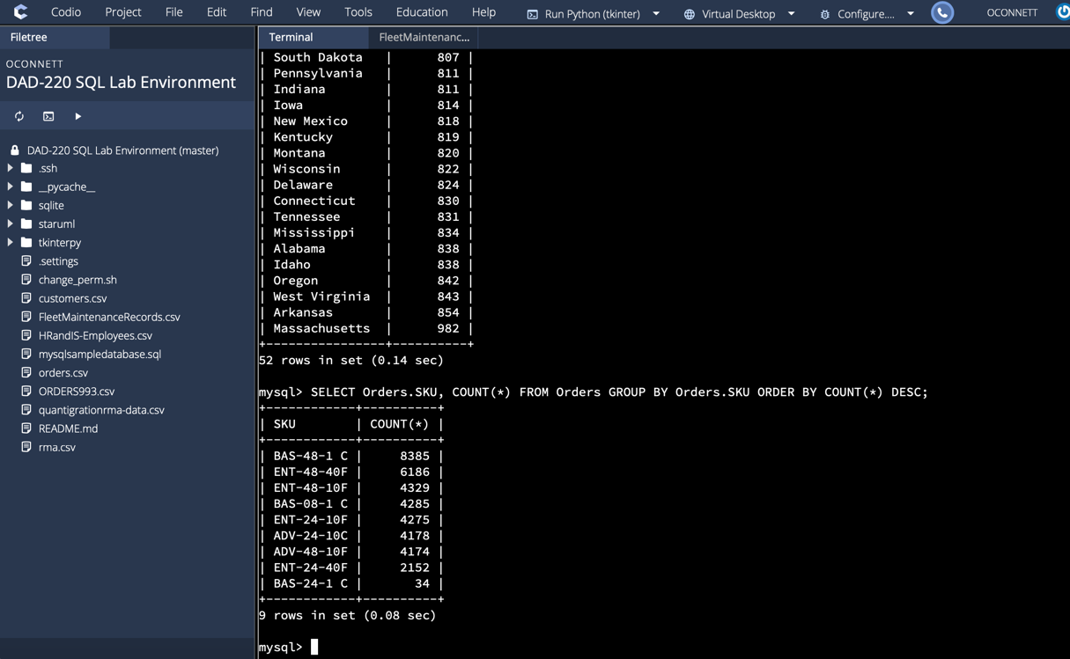
The top three products sold in the United States are BAS-48-1 C with 8385, ENT-48-40F with 6186, and ENT-48-10F with 4329.

    - Analyze the data to determine the top three products sold in the southeastern region of the United States.
      - Southeastern states to include in your analysis: Virginia, North Carolina, South Carolina, and Georgia
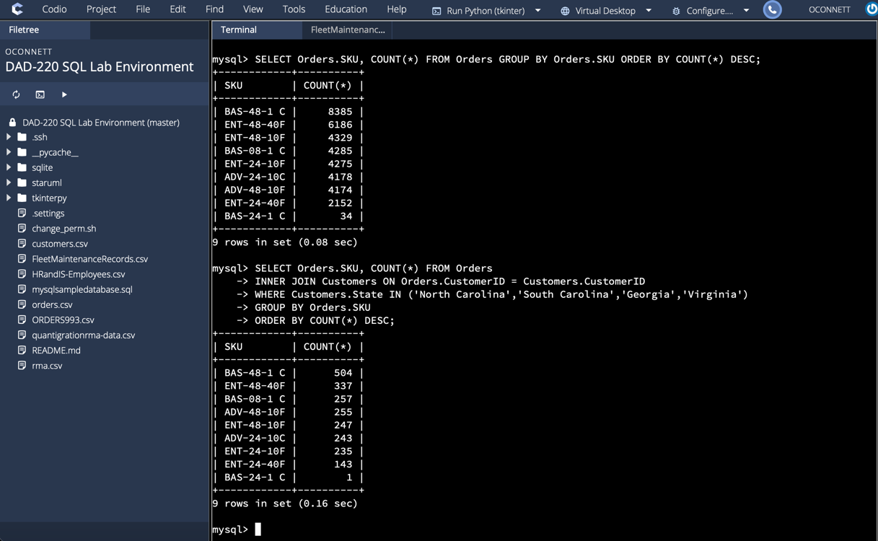
The top three products sold within the southeastern region include BAS-48-1 C with 504 units sold, ENT-48-40F with 337, and BAS-08-1 C with 257.
  - Returns by region:
    - Analyze the data to determine the top three products returned in the United States.
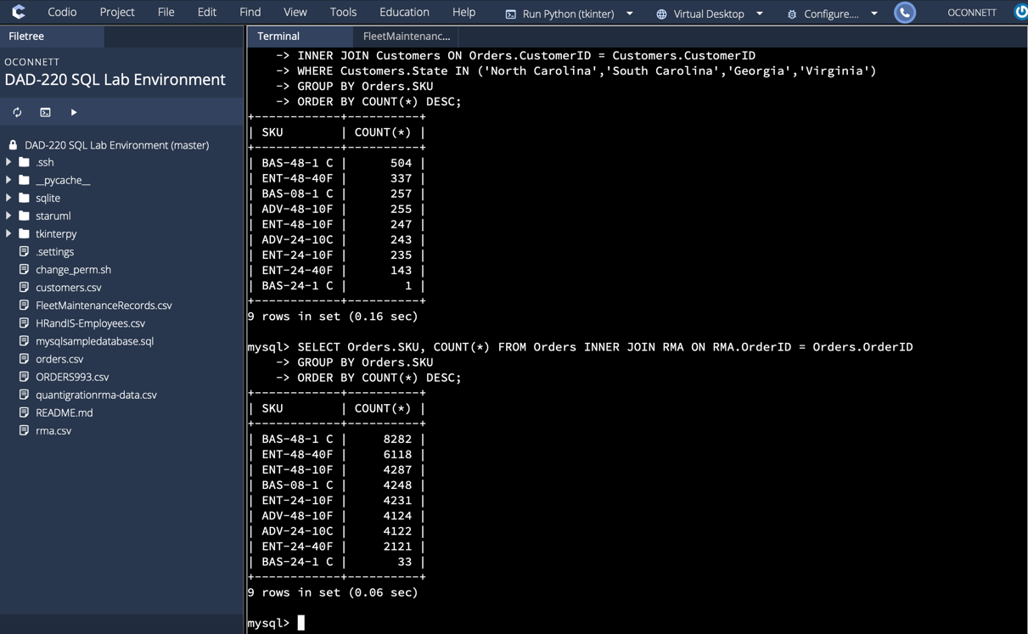
The top three products returned in the United States include BAS-48-1 C with 8282 returns, ENT-48-40F with 6118 returns, and ENT-48-10F with 4287 returns.
    - Analyze the data to determine the top three products returned in the northwestern region of the United States.
      - Northwestern states to include in your analysis: Washington, Oregon, Idaho, and Montana
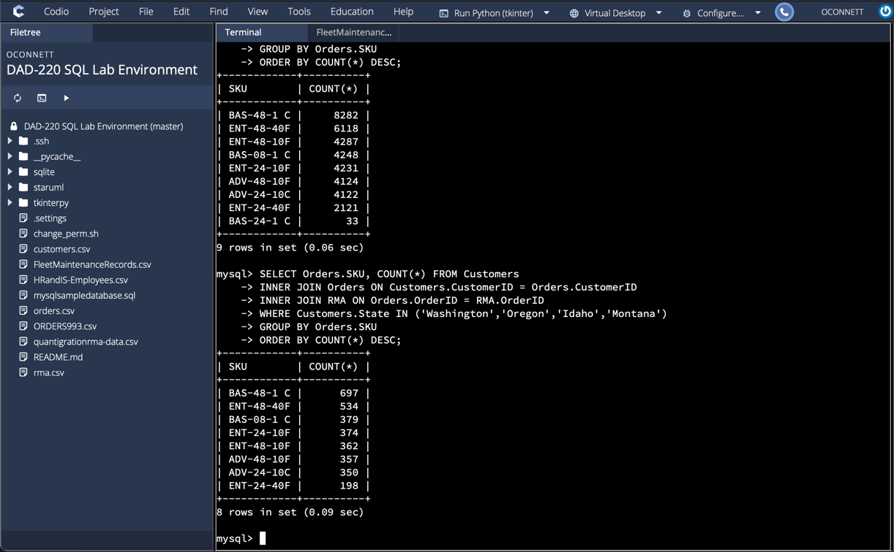
The top three products that were returned in the northwest region include BAS-48-1 C with 697 returns, ENT-48-40F with 534 returns, and BAS-08-1 C with 379 returns.
- Write a report to the Quantigration product manager that explains your findings in a way nontechnical stakeholders can digest and use.
  - This report should include an effective summary of the analysis of the captured data.
    - Sales data by region: Provide a well-written summary of your analysis on Part A.
In regards to sales for the company, the states of Massachusetts, Arkansas, and West Virginia are the top three locations, with the top 10 states in sales being located in the Eastern and Midwest regions of the United States. The top three products sold within the company include BAS-48-1 C with 8385 orders, ENT-48-40F with 6186 orders, and ENT-48-10F with 4329 orders. Within the southeastern region, the top three products sold include BAS-48-1 C, ENT-48-40F, and BAS-08-1 C. From this analysis, the company benefits from the orders of parts BAS-48-1 C and ENT-48-40F across the country.

    - Returns data by region: Provide a well-written summary of your analysis of Part B.

When analyzing the data for returns, it appears that BAS-48-1 C, ENT-48-40F, and ENT-48-10F are the most returned orders. Within the Northwest region, the top three returned orders include BAS-48-1-C, ENT-48-40F, and BAS-08-1 C. With this information, the company can focus on why orders such as BAS-48-1 C and ENT-48-40F are getting returned at a greater frequency than other products and how the Northwest region can improve the quality of those orders.

